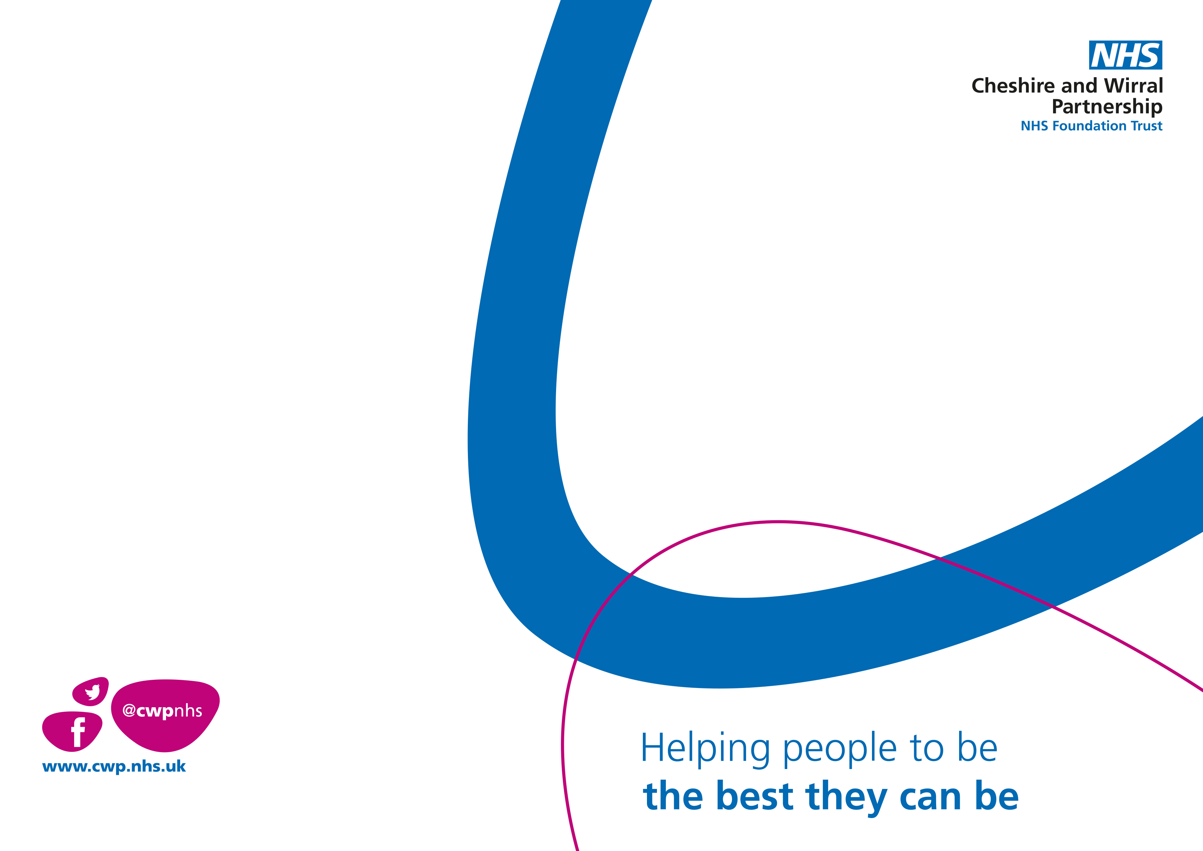

**Participation and Engagement Group**

Elm House Macclesfield

**Second session 20th June 2023**

Sessions will run once a Month at Elm House, Macclesfield.

Tuesday 3rd week of every month

Time: 4:30pm to 5:30pm

**If you are interested, please email:** [**cwp.camhs.macc@nhs.net**](mailto:cwp.camhs.macc@nhs.net)

**This Group will be led by young people.**

**An opportunity to share your voice**

**To give Feedback on the service**

**Are you interested in joining a CAMHS Participation Group this Spring to help us improve our service whilst meeting other people in a relaxed group?**

Ⓒ Copyright CWP NHS Foundation Trust (16/02/2023)