PR & Communications Toolkit for the Cheshire and Merseyside

Breathing Point website

A helpful resource for people with a

lung condition, including their

family, friends, and carers

April 2023

*IMMEDIATE*

For C&M ICB organisations’

Communications Teams and partners

Overview: New Breathing Point website resource

Lung Health in Cheshire and Merseyside

Respiratory disease affects 1 in 5 people in England and is the third biggest cause of death. Hospital admissions for lung disease have risen over the past seven years at three times the rate of all admissions generally and remain a major factor in the winter pressures faced by the NHS. In the North-West, we have one of the highest numbers of people living and diagnosed with Chronic Obstructive Pulmonary Disease (COPD) each year.

Good respiratory health is key to having a healthy population. NHS Cheshire and Merseyside, along with its partners, is targeting investment in improved treatment and support for those with respiratory disease, with an ambition to transform outcomes.

For many health conditions, people are already taking control themselves, supplemented with expert advice and peer support in the community and online. As part of a wider move to what The Kings Fund called ‘shared responsibility for health’ support for people to manage their own health is being promoted through respiratory education.

The Breathing Point website

The Cheshire and Merseyside Breathing Point website went live on 3rd April 2023, providing detailed information and signposting to the public, patients and health professionals in relation to lung conditions.

The site has been developed in collaboration with healthcare professionals, people affected by lung conditions, and carers.

Key aims of the website are:

- To provide simple and clear advice concerning respiratory conditions, self-management, and interventions
- Offer patients a local service finder across Cheshire and Merseyside. Information is available on healthcare including walk-in centres, GP practices, and lifestyle services such as walking groups or support groups
- Signpost patients to further information via external sites such as the NHS and Asthma + Lung UK
- Provide a community forum where patients and their families and carers can connect with others who are interested in lung health, lung conditions, treatment of lung conditions and new advances in medicines and technology
- Present the opportunity to ask questions or to add comments which will be regulated and monitored by local respiratory health care professionals
- Resources to guide and inform healthcare professionals looking to assist patients requesting additional information about their condition
- Introduce short films featuring specialist clinicians discussing a wide variety of lung conditions whilst also offering helpful advice and direction
- Support people with a lung condition about wellbeing and living a healthy lifestyle

Benefits

The website takes a person-centred approach: whether you are a patient/carer or health professional, the site is easy to navigate, and it is simple to access resources, information and support.

Benefits to patients and carers:

- Resources and information from a wide range of reputable organisations and health professionals has been brought together into one place - we have done the searching, so you don’t have to
- Includes links to resources to support lung condition education and management
- Empowering and informing patients with lung conditions to help gain a better understanding of their conditions including asthma, bronchiectasis, COPD, COVID-19, cystic fibrosis, lung cancer, pneumonia, pulmonary fibrosis, sleep apnoea, and tuberculosis.
- Quick and simple signposting to local services across Cheshire and Merseyside that can offer support or further information about their condition
- The opportunity to converse with fellow patients, make comments and ask questions moderated by lung and respiratory health professionals
- Direct links to external websites
- Includes easy read information and a comprehensive accessibility tool to accommodate different needs
- Informative videos featuring advice and guidance from leading clinicians and specialists
- The Breathing Point website is available in many different languages via Google translate

Benefits to health professionals:

- Support for health professionals across Cheshire and Merseyside to access and navigate up to date resources, information, and support, all in one place
- Patient questions answered by senior clinicians can be used as a resource guide
- Signposting to support patient care: easy access to a wide range of patient resources.
- Supports workforce learning and professional development

Get involved

NHS Cheshire and Merseyside (Integrated Care Board) staff and partner organisations are asked to promote the Breathing Point website widely, including to:
- NHS partners such as GPs, practice nurses, community pharmacies
- Local respiratory prevention groups or boards
- Local authority and public health colleagues
- Local residents
Promotional tools are supplied to target Cheshire and Merseyside residents and healthcare staff and encourage them to access the resources.

Promotional tools and digital assets

- Template news story - a news story which can be adapted to suit each local area/partner
- There will be a targeted public-facing (paid-for) C&M advertising campaign promoting the website across Facebook and Instagram for 10 weeks on launch
- Tweets – graphics suitable for Twitter are illustrated below along with example tweets
- Graphics for other digital channels
- Email footer – a promotional email footer for addition to email signatures

Creative examples

Breathing Point logo

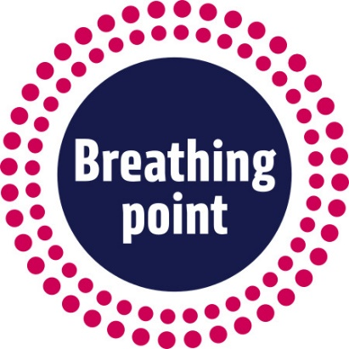

Breathing Point logo and supporting tagline

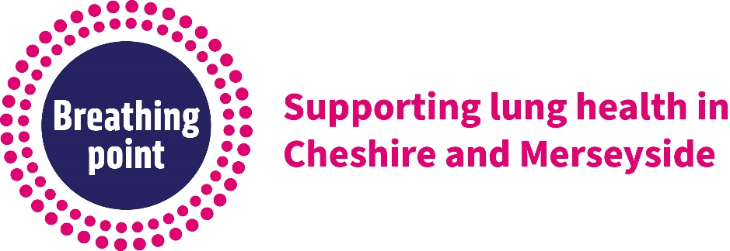

Lungs graphic

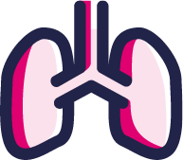

Person & lungs graphic

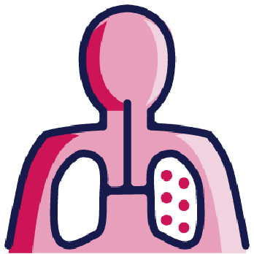

Social Media

The hashtag for the website is #BreathingPoint

Example posts and suggested images (please remember to adapt your text based on the character count for the platform you are using).

Public facing posts
- A new website has been launched to support lung health in Cheshire and Merseyside. For advice, signposting and resources to help you learn and understand more about your lung condition, go to BreathingPoint.co.uk #Breathing Point
Suggested images:

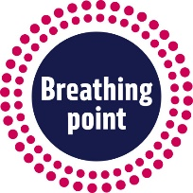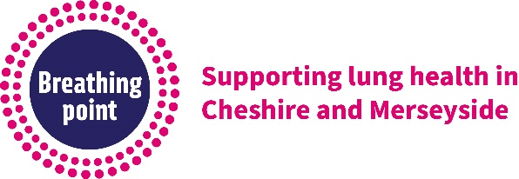

- If you are the carer of a person living with a lung condition, check out the new Breathing Point website. There’s lots of helpful information about conditions, interventions and treatments, plus there’s a community hub to connect with other carers. There’s also a service finder to discover what healthcare, activities and support groups are available in your area. BreathingPoint.co.uk
#BreathingPoint
Suggested images:

- If you want to learn more about a lung or respiratory illness, such as asthma, bronchiectasis, COPD, COVID-19, cystic fibrosis, lung cancer, pneumonia, pulmonary fibrosis, or tuberculosis, please go to BreathingPoint.co.uk
#BreathingPoint
Suggested images:

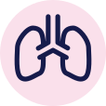

- Do you want to connect with other people who are living with a lung condition? Visit the Breathing Point Community Hub to find out more. Go to BreathingPoint.co.uk #BreathingPoint
Suggested images:

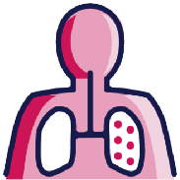

- To learn more about different interventions that could help you manage your lung condition, go to the new website at BreathingPoint.co.uk #BreathingPoint
Suggested images

- The Breathing Point website offers a brand new service finder to help people living with a lung condition find local services and support groups in their area. Take a look today! BreathingPoint.co.uk #BreathingPoint
Suggested images

Professional facing posts

- We have compiled resources relating to lung conditions for professionals to easily access via the new Breathing Point website. Visit BreathingPoint.co.uk for practical and helpful information. #BreathingPoint
Suggested images:

- For patient information about asthma, bronchiectasis, COPD, COVID-19, cystic fibrosis, lung cancer, pneumonia, pulmonary fibrosis, sleep apnoea, or tuberculosis, go to BreathingPoint.co.uk #BreathingPoint
Suggested images:

- (Add title) prevention month begins next week. Remember you can visit BreathingPoint.co.uk for information about lung conditions, interventions and to find local community health and lifestyle services. #BreathingPoint
Suggested images:

For further Place level information on lung and respiratory conditions, please click on the link: Service Finder Breathing Point

Email footer

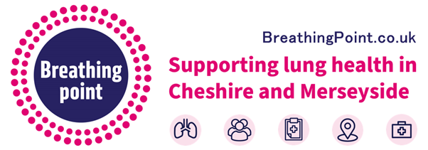

Website

Breathing Point Website – BreathingPoint.co.uk or www.breathingpoint.co.uk

Timelines

The new website content is now live.

A paid-for public-facing social media campaign across Facebook and Instagram will be launched across C&M (first 10 weeks) to compliment key public-facing messages outlined here, and to raise awareness of the website.

Potential tie ins with action dates are as follows:

Stress Awareness Month | April 2023 | Facebook/Instagram/Twitter  Living with a lung condition can be stressful. The Breathing Point website offers information, guidance and support to help. Visit today to find out more. Health and Wellbeing Breathing Point  #BreathingPoint  #StressAwarenessMonth
Move More Month | April 2023 | Facebook/Instagram/Twitter  Many people find that their lung symptoms are positively affected by exercise, a good diet, and a good sleep routine. To discover how, visit Exercise and Physical Activity Breathing Point  #BreathingPoint
World Health Day | 7th April 2023 | Facebook/Instagram/Twitter  If you have a lung condition, it can feel that there are barriers to you being able to exercise. However, being active in your day to day life can help you to manage your condition. To find out more about physical activity, go to Health and Wellbeing Breathing Point  #BreathingPoint  #WorldHealthDay2023
National Walking Month | May 2023 | Facebook/Instagram/Twitter  It’s National Walking Month, so for people living with a lung condition, why not check out Breathing Point’s Service Finder to see if there’s a walking group near you. Don’t delay, do it today!  Service Finder Breathing Point  #BreathingPoint  #NationalWalkingMonth
World Asthma Day | 3rd May 2023 | Facebook/Instagram/Twitter  On #World Asthma Day, if you want to learn more about this condition and see what support services are available in Cheshire and Merseyside, please go to Asthma Breathing Point  #BreathingPoint  #WorldAsthmaDay
Mental Health Awareness week | 9th -15th May 2023 | Facebook/Instagram/Twitter  A healthy lifestyle is beneficial for physical and mental health, but many people living with a lung condition also find that their symptoms are positively affected by a balanced diet, exercise, and a good sleep routine. Visit  Health and Wellbeing Breathing Point to find out more.  #BreathingPoint  #MentalHealthAwarenessWeek
World No Tobacco Day | 31st May 2023 | Facebook/Instagram/Twitter  If you smoke, then giving up is one of the best things you can do for your lungs and overall health. Smoking is a leading cause of lung disease and lung cancer. If you have a lung condition, the best treatment you can give yourself is to stop smoking. Find out more at Stopping Smoking Breathing Point  #BreathingPoint  #WorldNoTobaccoDay
Bike Week | 5th -11th June 2023 | Facebook/Instagram/Twitter  It’s #BikeWeekUK, and if you have a lung condition then physical exercise is one of the best treatments for living healthily. The Breathing Point website has lots of helpful information and advice on the benefits of an active lifestyle! Exercise and Physical Activity Breathing Point  #BreathingPoint  #BikeWeekUK
Carers’ Week | 6^{th –} 12th June 2023 | Facebook/Instagram/Twitter  If you’re a carer for a person with a lung condition, the Breathing Point website has lots of helpful information, guidance and treatments advice. There’s also a community hub to connect with other people interested in lung health and a service finder to find out what support is available in your area. Support for Carers Breathing Point  #BreathingPoint  #CarersWeek
Pulmonary Rehab Awareness Week | 19th – 23rd June | Facebook/Instagram/Twitter  Pulmonary rehabilitation (PR) is designed to improve the breathing and wellbeing of people with a lung condition. To see how PR’s exercise training, education and self-management skills could help you, go to Pulmonary Rehabilitation Breathing Point  #BreathingPoint
Love Your Lungs Week | 21st -27th June 2023 | Facebook/Instagram/Twitter  The Breathing Point website contains lots of information and helpful resources to support people who have a lung condition. The site has been developed in collaboration with people affected by lung conditions, carers and respiratory healthcare professionals. Find out more at BreathingPoint.co.uk  #BreathingPoint  #LoveYourLungsWeek
World Wellbeing Week | 26th -30th June 2023 | Facebook/Instagram/Twitter  It’s #World Wellbeing Week, so if you are living with a lung condition and need information, guidance and support then Breathing Point is the best one-stop shop website. There’s information on conditions, treatments and interventions, and there is a local service finder to discover what support and activities are available in your area. BreathingPoint.co.uk  #BreathingPoint  #WorldWellbeingWeek
World Bronchiectasis Day | 1st July 2023 | Facebook/Instagram/Twitter  It’s World Bronchiectasis Day and if you want to find out more information about this lung condition, go to Bronchiectasis Breathing Point There’s helpful guidance about symptoms, treatments and what to do if you are unwell.  #BreathingPoint  #WorldBronchiectasisDay
Pulmonary Fibrosis Awareness Month | September | Facebook/Instagram/Twitter  September is pulmonary fibrosis awareness month. If you are living with pulmonary fibrosis or are a carer of someone with the condition, please visit the website Pulmonary Fibrosis Breathing Point You’ll find lots of helpful information and guidance, plus there is a service finder to discover what support is available near you.  #BreathingPoint  #PulmonaryFibrosisAwarenessMonth
World Mental Health Day 2023 | 10th October 2023 | Facebook/Instagram/Twitter  Managing your lung condition can have a positive effect on your mental health. There is lots of information and helpful advice at the Breathing Point website. Feel free to ask questions about lung health, seek advice about services or look for people to connect with in your area. BreathingPoint.co.uk  #BreathingPoint  #WorldMentalHealthDay
Lung Cancer Awareness Month | November 2023 | Facebook/Instagram/Twitter  If you are living with lung cancer, the Breathing Point website provides lots of helpful information, guidance and links to lung cancer resources. There’s also a community hub where you can connect with other people living with lung conditions. Lung Cancer Breathing Point  #BreathingPoint  #LungCancerAwarenessMonth
World COPD Awareness Day | 21st November 2023 | Facebook/Instagram/Twitter  Chronic Obstructive Pulmonary Disease, or COPD, describes a group of lung conditions that cause air flow to be blocked due to a narrowing of the airways in the lungs. On #WorldCOPDDay if you want to learn more about this lung condition, then visit COPD Breathing Point  #BreathingPoint  #WorldCOPDDay
Carers’ Rights Day | 23rd November 2023 | Facebook/Instagram/Twitter  If you are the carer of a person living with a lung condition, check out the Breathing Point website. There’s lots of helpful information about conditions, interventions and treatments, plus there’s a community hub to connect with other carers. There’s also a service finder to discover what healthcare, activities, and support groups are available in your area. Support for Carers Breathing Point  #BreathingPoint  #CarersRightsDay
Time To Talk Day | 1st February 2024 | Facebook/Instagram/Twitter  If you are living with a lung condition or are supporting someone with a lung condition, then why not join the Breathing Point community hub to connect with people in similar circumstances. It offers the opportunity to ask questions, share comments and learn more about lung conditions, interventions and treatments. Why not visit today.  BreathingPoint.co.uk  #BreathingPoint  #TimeToTalk
World Cancer Day | 4th February 2024 | Facebook/Instagram/Twitter  If you are living with lung cancer, the Breathing Point website provides lots of helpful information, guidance and links to lung cancer resources. There’s also a community hub where you can connect with other people living with lung conditions. Lung Cancer Breathing Point  #BreathingPoint  #WorldCancerDay
Nutrition and Hydration Week | March 2024 | Facebook/Instagram/Twitter  A healthy diet supports the immune system to fight off infection. This is especially important for people with a lung condition. To find out more on how diet, nutrition and exercise can help you better manage your condition, go to Health and Wellbeing Breathing Point  #BreathingPoint  #NutritionAndHydrationWeek

Actions for local teams and partners

- Please liaise with local networks, organisations and groups, including NHS, public health and local authority partners to share the materials in this toolkit and promote the Breathing Point website.
- Start promoting the website through your usual communications channels, newsletters, on your website/intranet and to your partners using the suggested template news story attached.
- Start promoting the website to professionals and Cheshire and Merseyside residents through social media using the graphics/posts supplied.
- Add the Breathing Point email banner to your signature strip.

For more information, please contact:
barrie.farrell@nhs.net or kelly.smyth@innovationagencynwc.nhs.uk

